**Introduction**

The **Online Fire Reporting System** is a simple web-based application that helps people report fire incidents online. It is made for users to easily inform the fire department or concerned authorities about any fire accident by just filling out a form on a website. The system works through the internet and can be accessed from anywhere.

The main purpose of this system is to allow quick reporting of fire incidents so that help can arrive as soon as possible. In many cases, delays in reporting can lead to bigger losses. This system helps to reduce that delay by giving users a direct and simple way to send information quickly.

This project is especially helpful for homes, offices, schools, and public places were reporting a fire immediately can help save lives and property. It is better than traditional ways like making phone calls or filling out paper forms, which can take more time and might not be available in every situation.

With this system, users can report fire cases directly through a website. They can provide details like their name, location, and a short description of the fire. This information is then saved in a database so that fire officials or administrators can check it and take action.

**System Analysis**

System analysis is the process of studying and understanding how the current system works, identifying its problems, and defining the requirements for a new or improved system. In this project, we are developing a simple Online Fire Reporting System to make the fire incident reporting process faster and easier.

**Existing System**

* **Delayed Reporting and Response:** Calls to free phone numbers can be missed or delayed due to busy lines or unavailability of operators.
* **No Centralized Record Keeping:** Reports over phone are not systematically recorded, making tracking and follow-up difficult
* **Limited Accessibility:** People without phone access or in noisy /dangerous environments may be unable to report fires promptly
* **No Data Analytics or Reporting:** Lack of recorded data prevents analysis of fire trends, response times, or system improvements.
* **No feedback Mechanism for Reporter:** Callers cannot track the status of their reports or receive follow up information
* **Limited Accessibility for Hearing Impaired:** People who are deaf or have hearing difficulties cannot easily use phone calls to report emergencies

**PROPOSED SYSTEM**

* **Accessibility for All Users:** People with hearing or speech impairments can now report incidents through text-based forms, not just voice calls.
* **Faster Incident Reporting:** The system can generate reports and analytics based on incident history, helping authorities identify fire-prone areas and allocate resources better.
* **Incident Tracking and Updates:** Admins can update the status of each report, helping teams and users track progress if needed.
* **Location Accuracy:** Users can enter the exact address and optionally share a Google Maps link
* **Resource Allocation:** Admin can assign teams manually, and in the future, integrate automatic suggestions.
* **Documentation and History:** All data is stored in a database with secure access and backup.

**System Requirements Specifications**

**Hardware Configuration:**

**Client Side:**

|  |  |
| --- | --- |
| **RAM** | 512 MB |
|  |  |
| **Hard disk** | 10 GB |
|  |  |
| **Processor** | 1.0 GHz |
|  |  |

**Server side:**

|  |  |
| --- | --- |
| **RAM** | **1 GB** |
| **Hard disk** | **20 GB** |
| **Processor** | **2.0 GHz** |

**Software Requirement:**

**Client Side:**

|  |  |
| --- | --- |
| **Web Browser** | Google Chrome or any compatible browser |
| **Operating System** | Windows or any equivalent OS |

**Server Side:**

|  |  |
| --- | --- |
| **Web Server** | APACHE |
| **Server-side Language** | PHP5.6 or above version |
| **Database Server** | MYSQL |
| **Web Browser** | Google Chrome or any compatible browser |
| **Operating System** | Windows or any equivalent OS |

**APACHE**

The Apache HTTP Server Project is an effort to develop and maintain an open-source HTTP server for modern operating systems including UNIX and Windows. The goal of this project is to provide a secure, efficient and extensible server that provides HTTP services in sync with the current HTTP standards.

The Apache HTTP Server ("httpd") was launched in 1995 and it has been the most popular web server on the Internet since April 1996. It has celebrated its 20th birthday as a project in February 2015.

**PHP**

* PHP stands for PHP: Hypertext Preprocessor.
* PHP is a server-side scripting language, like ASP.
* PHP scripts are executed on the server.
* PHP supports many databases (MYSQL, Informix, Oracle, Sybase, Solid, Generic ODBC, etc.).
* PHP is an open source software.
* PHP is free to download and use.

**MYSQL**

* MYSQL is a database server
* MYSQL is ideal for both small and large applications
* MYSQL supports standard SQL
* MYSQL is free to download and use
* How to access MySQL: <http://localhost/phpmyadmin>

**SYSTEM DESIGN**

**Analysis:**

In present all fire incidents record work done on the paper. We can’t generate reports as per our requirements because it take more time to calculate the fire incidents record report.

**Disadvantage of present system:**

* **Not user friendly:** The present system not user friendly because data is not stored in structure and proper format.
* **Manual Control:** All report calculation is done manually so there is a chance of error.
* **Lots of paper work:** Fire incidents record maintains in the register so lots of paper require storing details.
* **Difficult to retrieve information:** Searching and retrieving specific incident records takes a lot of time and effort in a manual system
* **Time consuming:** The current paper-based system requires a lot of time for recording, updating and calculating fire incident data.

**System Design Introduction:**

Design is the first step in the development phase for any techniques and principles for the purpose of defining a device, a process or system in sufficient detail to permit its physical realization.

Once the software requirements have been analyzed and specified the software design involves three technical activities - design, coding, implementation and testing that are required to build and verify the software.

The design activities are of main importance in this phase, because in this activity, decisions ultimately affecting the success of the software implementation and its ease of maintenance are made. These decisions have the final bearing upon reliability and maintainability of the system. Design is the only way to accurately translate the customer’s requirements into finished software or a system.

Design is the place where quality is fostered in development. Software design is a process through which requirements are translated into a representation of software. Software design is conducted in two steps. Preliminary design is concerned with the transformation of requirements into data

**UML Diagrams:**

**Actor:**  
 A coherent set of roles that users of use cases play when interacting with the use cases.

**Use case:** A description of sequence of actions, including variants, that a system performs that yields an observable result of value of an actor.

UML stands for Unified Modeling Language. UML is a language for specifying, visualizing and documenting the system. This is the step while developing any product after analysis. The goal from this is to produce a model of the entities involved in the project which later need to be built. The representation of the entities that are to be used in the product being developed need to be designed.

**USE-CASE DIAGRAMS:**

Use case diagrams model behavior within a system and helps the developers understand of what the user require. The stick man represents what’s called an actor.

Use case diagram can be useful for getting an overall view of the system and clarifying who can do and more importantly what they can’t do.

Use case diagram consists of use cases and actors and shows the interaction between the use case and actors.

The purpose is to show the interactions between the use case and actor.

To represent the system requirements from user’s perspective.

An actor could be the end-user of the system or an external system.

**USECASE DIAGRAM**: A Use case is a description of set of sequence of actions. Graphically it is rendered as an ellipse with solid line including only its name. Use case diagram is a behavioral diagram that shows a set of use cases and actors and their relationship. It is an association between the use cases and actors. An actor represents a real-world object. Primary Actor – Sender, Secondary Actor Receiver.

**Use Case Diagrams:**

**Admin**

**Users**

**User**

**Class Diagram:**

A description of set of objects that share the same attributes operations, relationships, and semantics

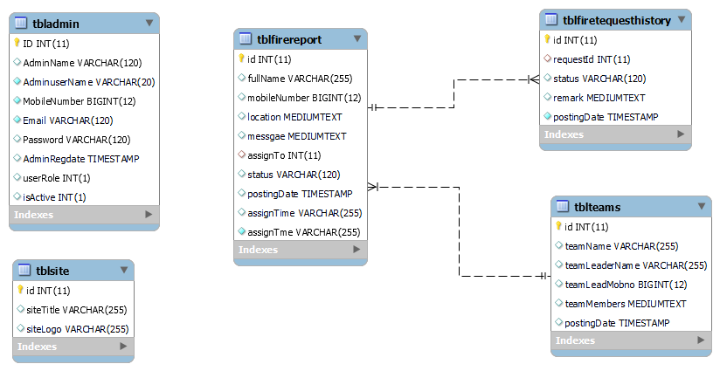

**ER Diagram:**

The Entity-Relationship (ER) model was originally proposed by Peter in 1976 [Chen76] as a way to unify the network and relational database views. Simply stated the ER model is a conceptual data model that views the real world as entities and relationships. A basic component of the model is the Entity-Relationship diagram which is used to visually represent data objects. Since Chen wrote his paper the model has been extended and today it is commonly used for database design for the database designer, the utility of the ER model is:

It maps well to the relational model. The constructs used in the ER model can easily be transformed into relational tables.

It is simple and easy to understand with a minimum of training. Therefore, the model can be used by the database designer to communicate the design to the end user.

In addition, the model can be used as a design plan by the database developer to implement a data model in specific database management software.

**ER Notation**

There is no standard for representing data objects in ER diagrams. Each modeling methodology uses its own notation. The original notation used by Chen is widely used in academics texts and journals but rarely seen in either CASE tools or publications by non-academics. Today, there are a number of notations used; among the more common are Bachman, crow's foot, and IDEFIX.

All notational styles represent entities as rectangular boxes and relationships as lines connecting boxes. Each style uses a special set of symbols to represent the cardinality of a connection. The notation used in this document is from Martin. The symbols used for the basic ER constructs are:

Entities are represented by labeled rectangles. The label is the name of the entity. Entity names should be singular nouns.

Relationships are represented by a solid line connecting two entities. The name of the relationship is written above the line. Relationship names should be verbs

Attributes, when included, are listed inside the entity rectangle. Attributes which are identifiers are underlined. Attribute names should be singular nouns.

Cardinality of many is represented by a line ending in a crow's foot. If the crow's foot is omitted, the cardinality is one.

Existence is represented by placing a circle or a perpendicular bar on the line. Mandatory existence is shown by the bar (looks like a 1) next to the entity for an instance is required. Optional existence is shown by placing a circle next to the entity that is optional.

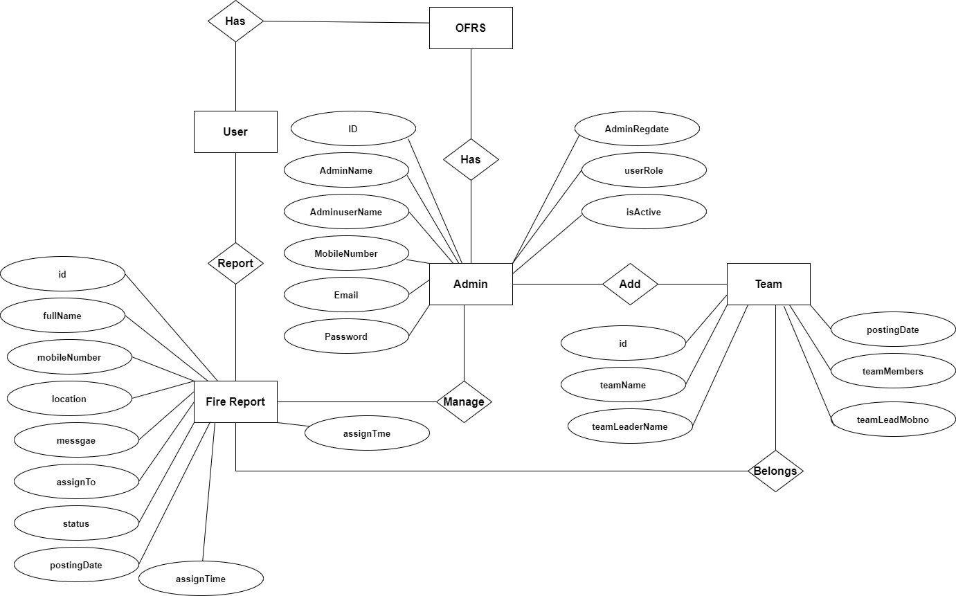

**Data Flow Diagram**

DFD graphically representing the functions, or processes, which capture, manipulate, store, and distribute data between a system and its environment and between components of a system. The visual representation makes it a good communication tool between User and System designer. Structure of DFD allows starting from a broad overview and expand it to a hierarchy of detailed diagrams. DFD has often been used due to the following reasons:

* Logical information flow of the system
* Determination of physical system construction requirements
* Simplicity of notation

**Zero Level DFD**

**Team Management**

**Password Management**

**Fire Report Management**

**Website**

**Management**

**Login Management**

**First Level DFD**

**Password Management**

**Team Management**

**Fire Report Management**

**Generate Reports**

**Login Management**

**Admin Management**

**Second Level DFD**

**Admin**

**Manage Fire Team**

**Manage Fire Report**

**Generate Report**

**Manage Website**

**Update Profile**

**Change Password**

**Users**

**ok**

**Report For Fire**

**Search the status of fire**

**View Website**

**MySQL Data Tables:**

**Admin Table :**(Table name is tbladmin)

This store admin personal and login details.

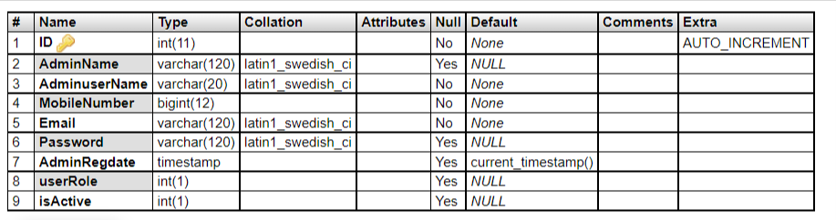

**Fire Report Table**: (Table name is tblfirereport)

This table store tee details of fire report by users

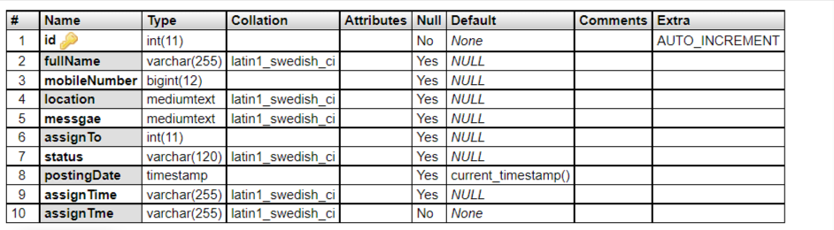

**Request History Table:** (Table name is tblfiretequesthistory)

This table store the details of request history of fire reporting.

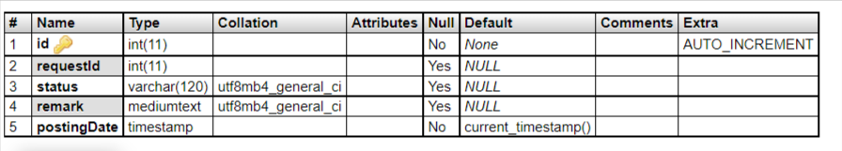

**Website Table:** (Table name is tblsite)

This table store the details of website.

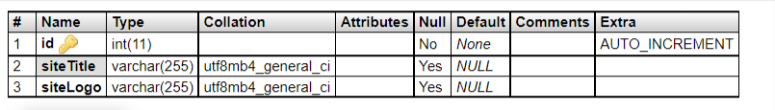

**Fire Team Table:** (Table name is tblsite)

This table store the details of fire team who handling fire incidents.

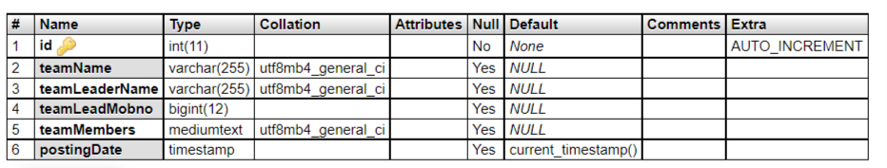

**Implementation**

The implementation of the **Online Fire Reporting System** will be carried out in several key phases to ensure a smooth and successful launch. The first phase involves the **design and development** of the system, where basic user interfaces and the reporting form will be created using simple web technologies. This will include a form where users can enter the type of fire, location details, and contact information. The backend will store reports in a database accessible to fire service personnel.

Once development is complete, the second phase focuses on **testing and debugging**. The system will be tested internally to ensure that reports are submitted correctly and data is being stored securely. Any technical issues will be resolved during this stage to ensure smooth operation during public use.

The third phase will involve a **pilot launch**, where the system will be introduced in a small area or community for trial use. Feedback from users and fire service staff will be collected to improve usability and efficiency. After successful testing, the final phase will be a **full-scale rollout**, making the system available to the entire target region.

Training materials and **user guides** will be prepared to help both the public and fire department staff understand how to use the system effectively. Finally, the system will be **monitored and maintained** regularly to fix bugs, improve performance, and ensure data privacy and security are upheld.

**System Testing**

The goal of the system testing process was to determine all faults in our project. The program was subjected to a set of test inputs and many explanations were made and based on these explanations it will be decided whether the program behaves as expected or not. Our Project went through two levels of testing

1. Unit testing

2. Integration testing

**UNIT TESTING**

Unit testing is commenced when a unit has been created and effectively reviewed .In order to test a single module we need to provide a complete environment i.e. besides the section we would require

* The procedures belonging to other units that the unit under test calls
* Non local data structures that module accesses
* A procedure to call the functions of the unit under test with appropriate parameters

**1. Test for the admin module**

* **Testing admin login form-**This form is used for log in of administrator of the system. In this form we enter the username and password if both are correct administration page will open otherwise if any of data is wrong it will get redirected back to the login page and again ask the details.
* **Report Generation:** admin can generate report from the main database.

**INTEGRATION TESTING**

In the Integration testing we test various combination of the project module by providing the input.

The primary objective is to test the module interfaces in order to confirm that no errors are occurring when one module invokes the other module.

**FEASIBILITY ANALYSIS**

A **Feasibility Analysis for an Online Fire Reporting System** evaluates whether it's practical, viable, and beneficial to implement such a system. Here's a detailed breakdown of the main aspects of feasibility:

**1. Technical Feasibility**

The online fire reporting system can be built using basic web technologies and a simple database. It does not require complex tools, making it easy to develop and maintain. Most users will be able to access it using a browser on a phone or computer. The system can handle simple form submissions and store reports securely. Overall, it is technically possible to create and run this system with minimal resources.

**2. Operational Feasibility**

The system is simple enough to be used by both the public and emergency staff with little training. Fire departments can receive reports quickly and act faster than through traditional methods. Users will only need to fill out a short form with basic details of the fire. With clear instructions, even non-technical users can use the platform easily. This makes the system practical and useful in daily operations.

**3. Economic Feasibility**

The project does not require a large budget as it uses basic technology and can be developed by a small team. The main costs involve development, basic hosting, and maintenance. Over time, it can reduce losses by enabling faster fire response. It also reduces reliance on phone calls and paperwork, saving time and money. Therefore, the benefits are greater than the costs involved.

**4. Legal and Ethical Feasibility**

The system must protect users' personal information and follow basic data protection rules. Information should only be used by authorized emergency personnel. There should be clear terms of use to avoid misuse and false reporting. Ethical use includes fair access for everyone and not collecting unnecessary data. With simple privacy and security measures, it is legally and ethically acceptable.

**5. Schedule Feasibility**

This project can be completed in a short time, depending on team size and resources. A basic version can be developed in about two to three months. Time is also needed for testing and feedback from users and fire staff. A phased launch can help identify and fix issues early. With a clear plan, the system can be delivered on schedule.

**CODING**

**DASHBOARD**

<?php

session_start();

include_once('includes/config.php');

if (strlen($_SESSION['aid']==0)) {

  header('location:logout.php');

  } else{

?>

<!DOCTYPE html>

<html lang="en">

<head>

    <meta charset="utf-8">

    <meta http-equiv="X-UA-Compatible" content="IE=edge">

    <meta name="viewport" content="width=device-width, initial-scale=1, shrink-to-fit=no">

    <meta name="description" content="">

    <meta name="author" content="">

    <title>Dashboard</title>

    <!-- Custom fonts for this template-->

    <link href="vendor/fontawesome-free/css/all.min.css" rel="stylesheet" type="text/css">

    <link

        href="https://fonts.googleapis.com/css?family=Nunito:200,200i,300,300i,400,400i,600,600i,700,700i,800,800i,900,900i"

        rel="stylesheet">

    <!-- Custom styles for this template-->

    <link href="css/sb-admin-2.min.css" rel="stylesheet">

</head>

<body id="page-top">

    <!-- Page Wrapper -->

    <div id="wrapper">

        <!-- Sidebar -->

       <?php include_once('includes/sidebar.php');?>

        <!-- End of Sidebar -->

        <!-- Content Wrapper -->

        <div id="content-wrapper" class="d-flex flex-column">

            <!-- Main Content -->

            <div id="content">

                <!-- Topbar -->

<?php include_once('includes/topbar.php');?>

                <!-- End of Topbar -->

                <!-- Begin Page Content -->

                <div class="container-fluid">

                    <!-- Page Heading -->

                    <div class="d-sm-flex align-items-center justify-content-between mb-4">

                        <h1 class="h3 mb-0 text-gray-800">Dashboard</h1>

              <!--           <a href="registrations.php" class="d-none d-sm-inline-block btn btn-sm btn-primary shadow-sm"><i

                                class="fas fa-download fa-sm text-white-50"></i> Generate Report</a> -->

                    </div>

                    <!-- Content Row -->

                    <div class="row">

<?php

//Total

$query=mysqli_query($con,"select id from tblfirereport");

$totalreportings=mysqli_num_rows($query);

$query1=mysqli_query($con,"select id from tblfirereport where status='Request Completed'");

$requestcompleted=mysqli_num_rows($query1);

$query11=mysqli_query($con,"select id from tblfirereport where status='Assigned'");

$assignedrequests=mysqli_num_rows($query11);

$query2=mysqli_query($con,"select id from tblfirereport where status='Team On the Way'");

$tonthewayreq=mysqli_num_rows($query2);

$query3=mysqli_query($con,"select id from tblfirereport where status='Fire Relief Work in Progress'");

$frwprequests=mysqli_num_rows($query3);

$query4=mysqli_query($con,"select id from tblfirereport where status is null");

$newrequests=mysqli_num_rows($query4);

?>

                  <div class="col-xl-4 col-md-6 mb-4">

                            <div class="card border-left-danger shadow h-100 py-2">

                                <a href="new-requests.php">

                                <div class="card-body">

                                    <div class="row no-gutters align-items-center">

                                        <div class="col mr-2">

                                            <div class="text-xs font-weight-bold text-danger text-uppercase mb-1"> New Fire Requests

                                            </div>

                                            <div class="row no-gutters align-items-center">

                                                <div class="col-auto">

                                                    <div class="h5 mb-0 mr-3 font-weight-bold text-gray-800"><?php echo $newrequests;?></div>

                                                </div>

                                                <div class="col">

                                                </div>

                                            </div>

                                        </div>

                                        <div class="col-auto">

                                            <i class="fa fa-fire fa-2x text-gray"></i>

                                        </div>

                                    </div>

                                </div>

                            </a>

                            </div>

                        </div>

                        <div class="col-xl-4 col-md-6 mb-4">

                            <div class="card border-left-primary shadow h-100 py-2">

                                <a href="all-requests.php">

                                <div class="card-body">

                                    <div class="row no-gutters align-items-center">

                                        <div class="col mr-2">

                                            <div class="text-xs font-weight-bold text-primary text-uppercase mb-1">

                                             Total Fire Reportings</div>

                                            <div class="h5 mb-0 font-weight-bold text-gray-800"><?php echo $totalreportings;?></div>

                                        </div>

                                        <div class="col-auto">

                                            <i class="fas fa-fire fa-2x text-red-300"></i>

                                        </div>

                                    </div>

                                </div>

                            </a>

                            </div>

                        </div>

                        <div class="col-xl-4 col-md-6 mb-4">

                            <div class="card border-left-success shadow h-100 py-2">

                                <a href="completed-requests.php">

                                <div class="card-body">

                                    <div class="row no-gutters align-items-center">

                                        <div class="col mr-2">

                                            <div class="text-xs font-weight-bold text-success text-uppercase mb-1">

                                              Fire Request Completed</div>

                                            <div class="h5 mb-0 font-weight-bold text-gray-800"><?php echo $requestcompleted;?></div>

                                        </div>

                                        <div class="col-auto">

                                            <i class="fas fa-fire fa-2x text-red-300"></i>

                                        </div>

                                    </div>

                                </div>

                            </a>

                            </div>

                        </div>

                        <div class="col-xl-4 col-md-6 mb-4">

                            <div class="card border-left-info shadow h-100 py-2">

                                <a href="assigned-requests.php">

                                <div class="card-body">

                                    <div class="row no-gutters align-items-center">

                                        <div class="col mr-2">

                                            <div class="text-xs font-weight-bold text-info text-uppercase mb-1">Assigned Fire Requests

                                            </div>

                                            <div class="row no-gutters align-items-center">

                                                <div class="col-auto">

                                                    <div class="h5 mb-0 mr-3 font-weight-bold text-gray-800"><?php echo $assignedrequests;?></div>

                                                </div>

                                                <div class="col">

                                                </div>

                                            </div>

                                        </div>

                                        <div class="col-auto">

                                            <i class="fas fa-fire fa-2x text-gray-300"></i>

                                        </div>

                                    </div>

                                </div>

                            </a>

                            </div>

                        </div>

     <div class="col-xl-4 col-md-6 mb-4">

                            <div class="card border-left-warning shadow h-100 py-2">

                                <a href="team-ontheway-requests.php">

                                <div class="card-body">

                                    <div class="row no-gutters align-items-center">

                                        <div class="col mr-2">

                                            <div class="text-xs font-weight-bold text-warning text-uppercase mb-1"> Team On the Way Requests

                                            </div>

                                            <div class="row no-gutters align-items-center">

                                                <div class="col-auto">

                                                    <div class="h5 mb-0 mr-3 font-weight-bold text-gray-800"><?php echo $tonthewayreq;?></div>

                                                </div>

                                                <div class="col">

                                                </div>

                                            </div>

                                        </div>

                                        <div class="col-auto">

                                            <i class="fas fa-fire fa-2x text-gray-300"></i>

                                        </div>

                                    </div>

                                </div>

                            </a>

                            </div>

                        </div>

                        <div class="col-xl-4 col-md-6 mb-4">

                            <div class="card border-left-info shadow h-100 py-2">

                                <a href="workin-progress-requests.php">

                                <div class="card-body">

                                    <div class="row no-gutters align-items-center">

                                        <div class="col mr-2">

                                            <div class="text-xs font-weight-bold text-info text-uppercase mb-1">

                                            Fire Relief Work in Progress</div>

                                            <div class="h5 mb-0 font-weight-bold text-gray-800"><?php echo $frwprequests;?></div>

                                        </div>

                                        <div class="col-auto">

                                            <i class="fa fa-fire fa-2x text-gray-300"></i>

                                        </div>

                                    </div>

                                </div>

                            </a>

                            </div>

                        </div>

                    </div>

                    <!-- Content Row -->

            <!-- Footer -->

       <?php include_once('includes/footer.php');?>

            <!-- End of Footer -->

        </div>

        <!-- End of Content Wrapper -->

    </div>

    <!-- End of Page Wrapper -->

    <!-- Scroll to Top Button-->

           <?php include_once('includes/footer2.php');?>

    <!-- Bootstrap core JavaScript-->

    <script src="vendor/jquery/jquery.min.js"></script>

    <script src="vendor/bootstrap/js/bootstrap.bundle.min.js"></script>

    <!-- Core plugin JavaScript-->

    <script src="vendor/jquery-easing/jquery.easing.min.js"></script>

    <!-- Custom scripts for all pages-->

    <script src="js/sb-admin-2.min.js"></script>

    <!-- Page level plugins -->

    <script src="vendor/chart.js/Chart.min.js"></script>

    <!-- Page level custom scripts -->

    <script src="js/demo/chart-area-demo.js"></script>

    <script src="js/demo/chart-pie-demo.js"></script>

</body>

</html>

<?php } ?>

**NEW REQUEST**

<?php session_start();

//DB conncetion

include_once('includes/config.php');

error_reporting(0);

//validating Session

if (strlen($_SESSION['aid']==0)) {

  header('location:logout.php');

  } else{

//Code for record deletion

if($_GET['teamid']){

$tid=$_GET['teamid'];

mysqli_query($con,"delete from tblteams where id ='$tid'");

echo "<script>alert('Data Deleted');</script>";

echo "<script>window.location.href='manage-teams.php'</script>";

          }

?>

<!DOCTYPE html>

<html lang="en">

<head>

    <meta charset="utf-8">

    <meta http-equiv="X-UA-Compatible" content="IE=edge">

    <meta name="viewport" content="width=device-width, initial-scale=1, shrink-to-fit=no">

    <meta name="description" content="">

    <meta name="author" content="">

    <title>Manage New Fire Reporting</title>

    <!-- Custom fonts for this template -->

    <link href="vendor/fontawesome-free/css/all.min.css" rel="stylesheet" type="text/css">

    <link

        href="https://fonts.googleapis.com/css?family=Nunito:200,200i,300,300i,400,400i,600,600i,700,700i,800,800i,900,900i"

        rel="stylesheet">

    <!-- Custom styles for this template -->

    <link href="css/sb-admin-2.min.css" rel="stylesheet">

    <!-- Custom styles for this page -->

    <link href="vendor/datatables/dataTables.bootstrap4.min.css" rel="stylesheet">

</head>

<body id="page-top">

    <!-- Page Wrapper -->

    <div id="wrapper">

        <!-- Sidebar -->

  <?php include_once('includes/sidebar.php');?>

        <!-- End of Sidebar -->

        <!-- Content Wrapper -->

        <div id="content-wrapper" class="d-flex flex-column">

            <!-- Main Content -->

            <div id="content">

                <!-- Topbar -->

<?php include_once('includes/topbar.php');?>

                <!-- End of Topbar -->

                <!-- Begin Page Content -->

                <div class="container-fluid">

                    <!-- Page Heading -->

                       <div class="d-sm-flex align-items-center justify-content-between mb-4">

                        <h1 class="h3 mb-0 text-gray-800">Manage New Fire Reporting</h1>

                    </div>

                    <!-- DataTales Example -->

                    <div class="card shadow mb-4">

                        <div class="card-header py-3">

                            <h6 class="m-0 font-weight-bold text-primary">Fire Reporting Information</h6>

                        </div>

                        <div class="card-body">

                            <div class="table-responsive">

                                <table class="table table-bordered" id="dataTable" width="100%" cellspacing="0">

                                    <thead>

                                        <tr>

                                            <th>Sno.</th>

                                            <th>Name</th>

                                            <th>Mobile Number</th>

                                            <th>Location </th>

                                             <th>Message</th>

                                             <th>Reporting Time</th>

                                            <th>Action</th>

                                        </tr>

                                    </thead>

                                    <tfoot>

                                     <tr>

                                            <th>Sno.</th>

                                            <th>Name</th>

                                            <th>Mobile Number</th>

                                            <th>Location </th>

                                             <th>Message</th>

                                             <th>Reporting Time</th>

                                            <th>Action</th>

                                        </tr>

                                    </tfoot>

                                    <tbody>

<?php $query=mysqli_query($con,"select * from tblfirereport where status is null");

$cnt=1;

while($row=mysqli_fetch_array($query)){

?>

                                        <tr>

                                            <td><?php echo $cnt;?></td>

                                            <td><?php echo $row['fullName'];?></td>

                                            <td><?php echo $row['mobileNumber'];?></td>

                                            <td><?php echo $row['location'];?></td>

                                            <td><?php echo $row['messgae'];?></td>

                                            <td><?php echo $row['postingDate'];?></td>

                                            <td>

                                <a href="request-details.php?requestid=<?php echo $row['id'];?>" class="btn-sm btn-primary">View</a>

                              </td>

                                        </tr>

                               <?php $cnt++;

                           } ?>

                                    </tbody>

                                </table>

                            </div>

                        </div>

                    </div>

                </div>

                <!-- /.container-fluid -->

            </div>

            <!-- End of Main Content -->

            <!-- Footer -->

    <?php include_once('includes/footer.php');?>

            <!-- End of Footer -->

        </div>

        <!-- End of Content Wrapper -->

    </div>

    <!-- End of Page Wrapper -->

    <!-- Scroll to Top Button-->

    <?php include_once('includes/footer2.php');?>

    <!-- Bootstrap core JavaScript-->

    <script src="vendor/jquery/jquery.min.js"></script>

    <script src="vendor/bootstrap/js/bootstrap.bundle.min.js"></script>

    <!-- Core plugin JavaScript-->

    <script src="vendor/jquery-easing/jquery.easing.min.js"></script>

    <!-- Custom scripts for all pages-->

    <script src="js/sb-admin-2.min.js"></script>

    <!-- Page level plugins -->

    <script src="vendor/datatables/jquery.dataTables.min.js"></script>

    <script src="vendor/datatables/dataTables.bootstrap4.min.js"></script>

    <!-- Page level custom scripts -->

    <script src="js/demo/datatables-demo.js"></script>

</body>

</html>

<?php } ?>

**SCREENSHOT**

**Home Page**

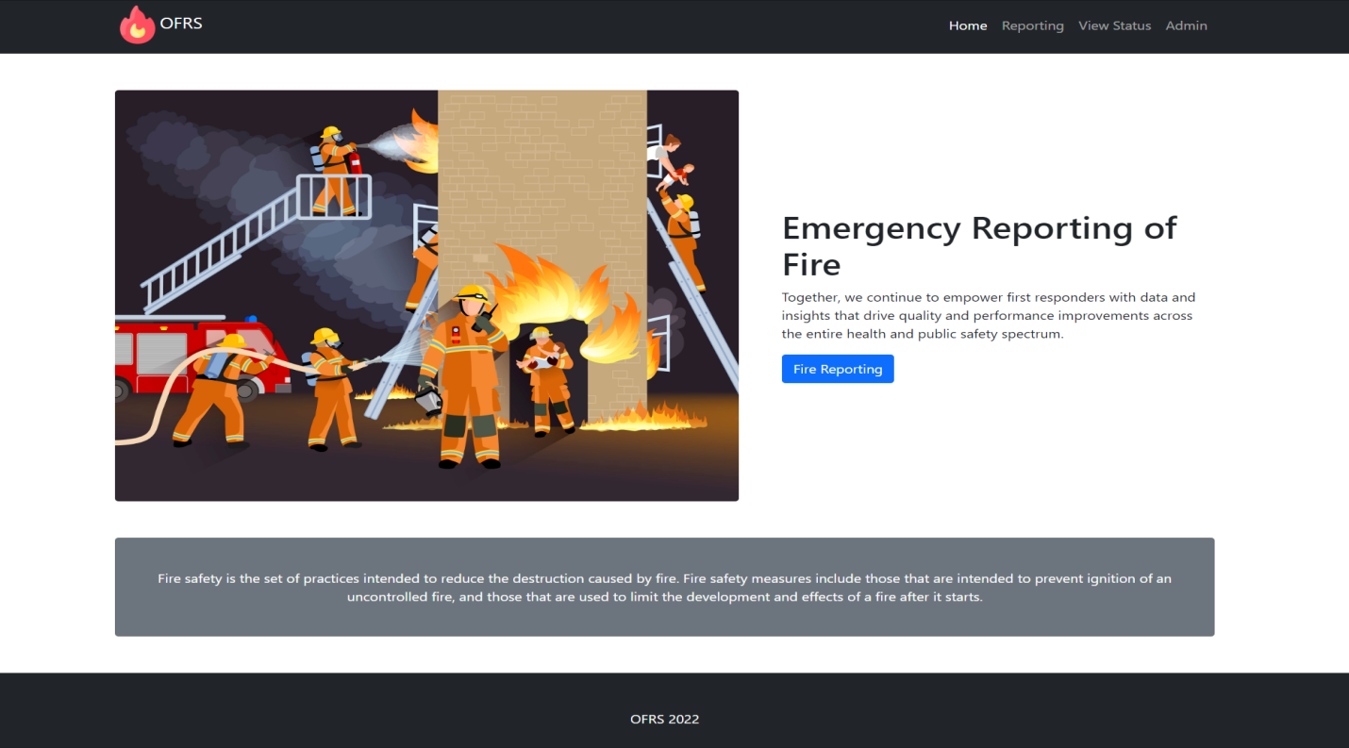

**Fire Reporting**

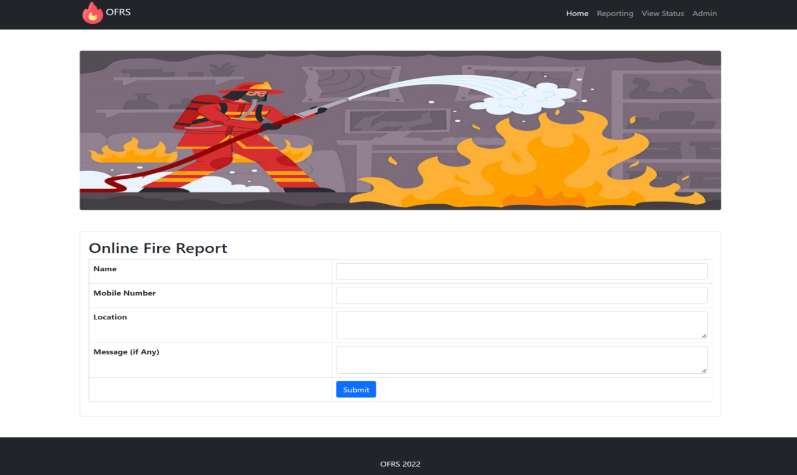

**Search Status**

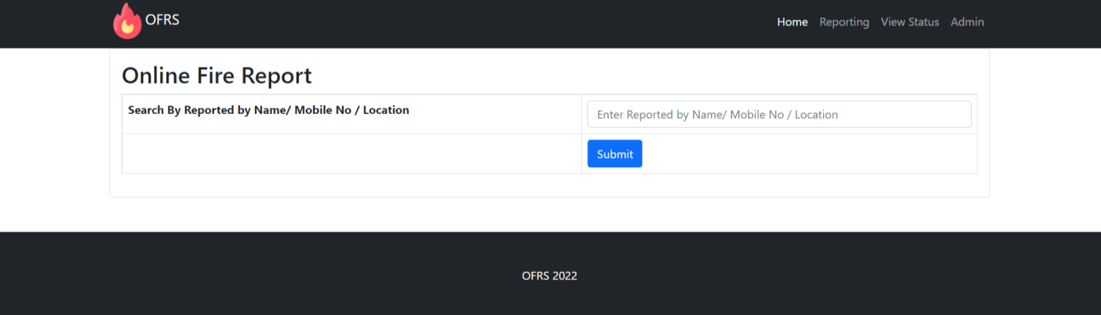

**View Search Status**

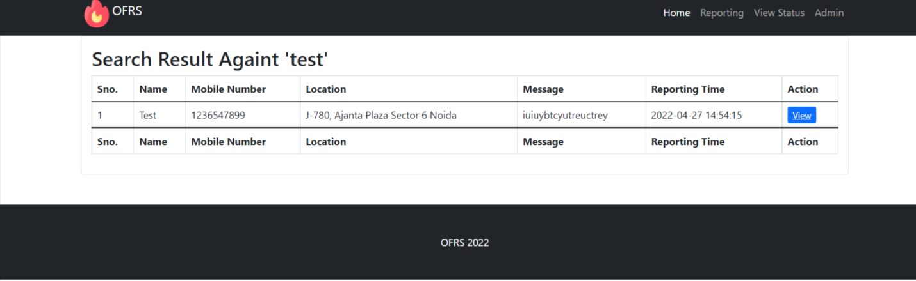

**Admin Login**

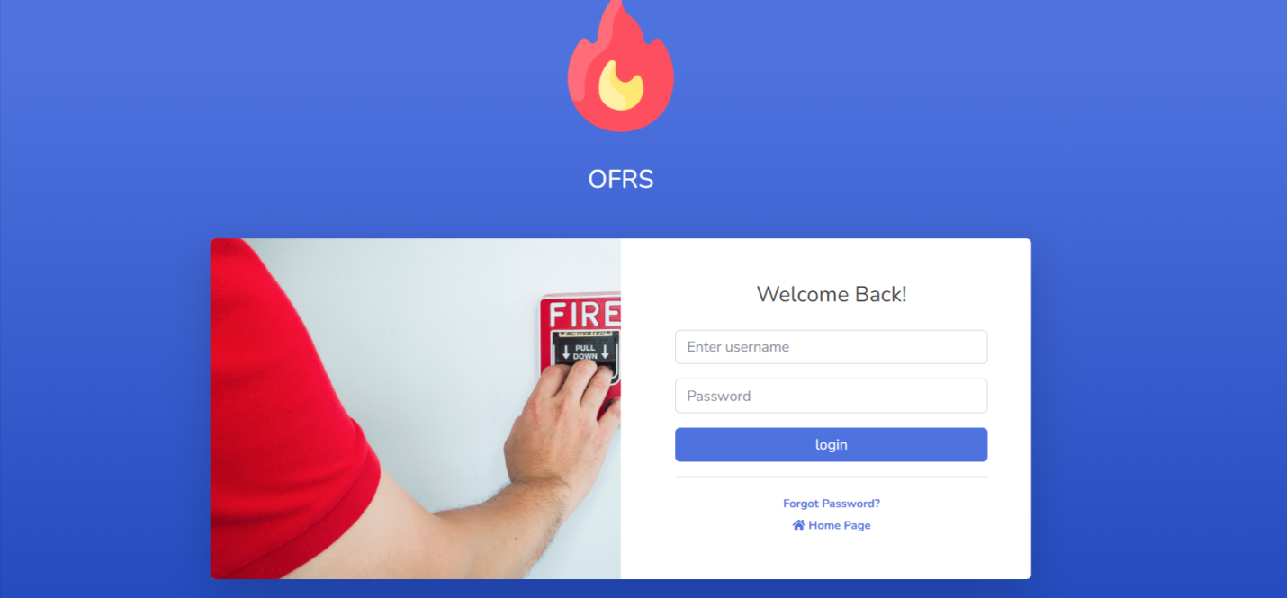

**Dashboard**

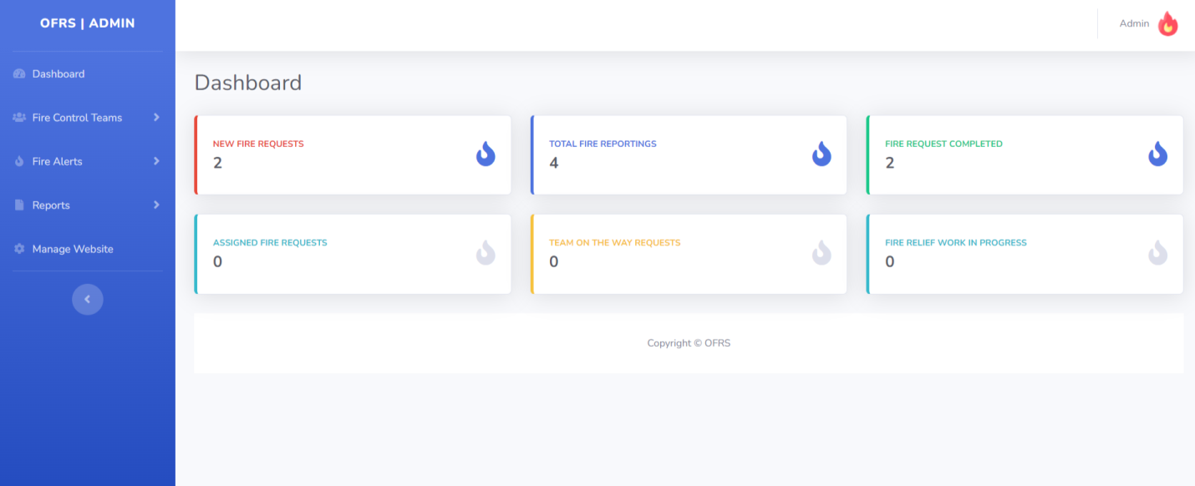

**Profile**

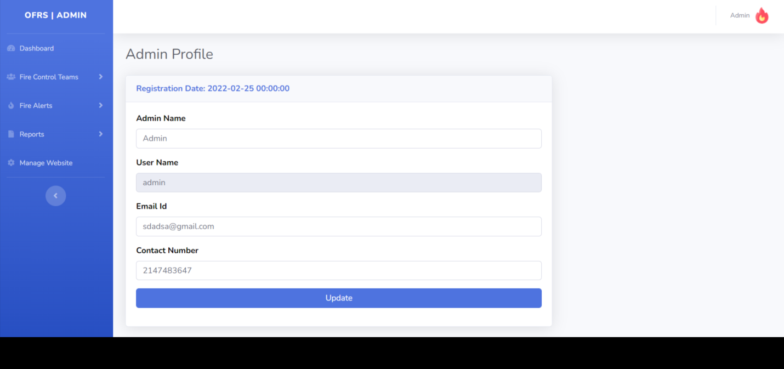

**Change Password**

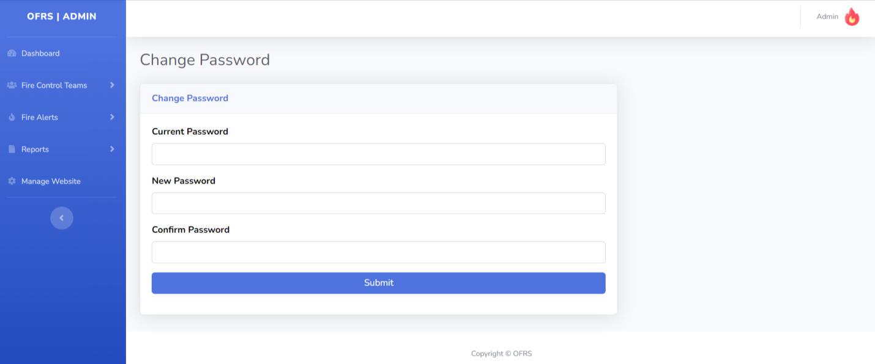

**Add Team**

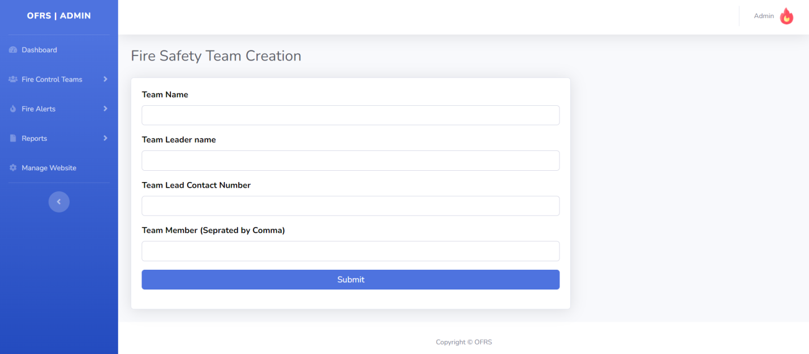

**Manage Team**

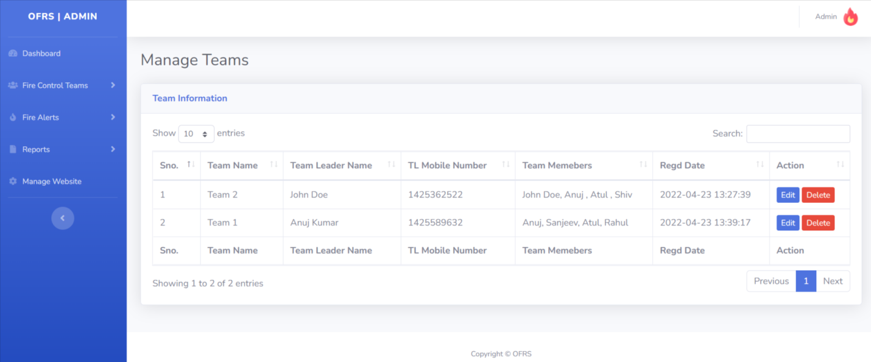

**Update Team details**

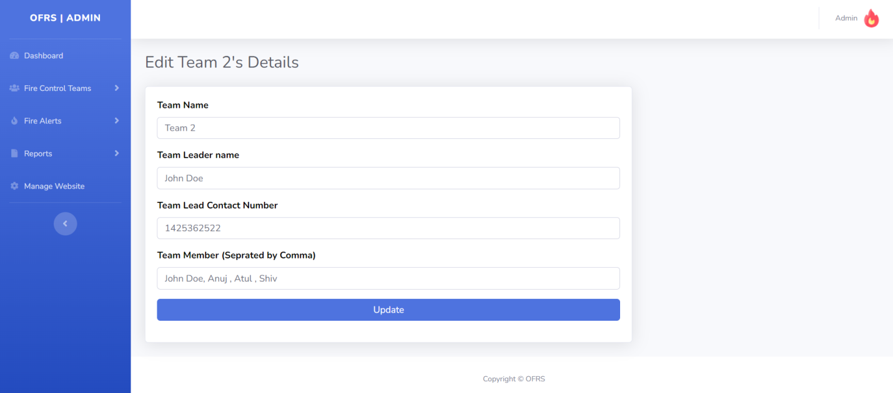

**New Fire Alerts**

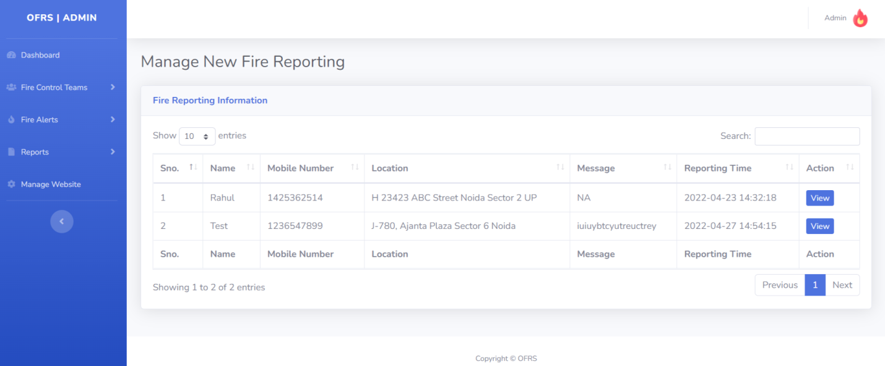

**View New Fire Alerts**

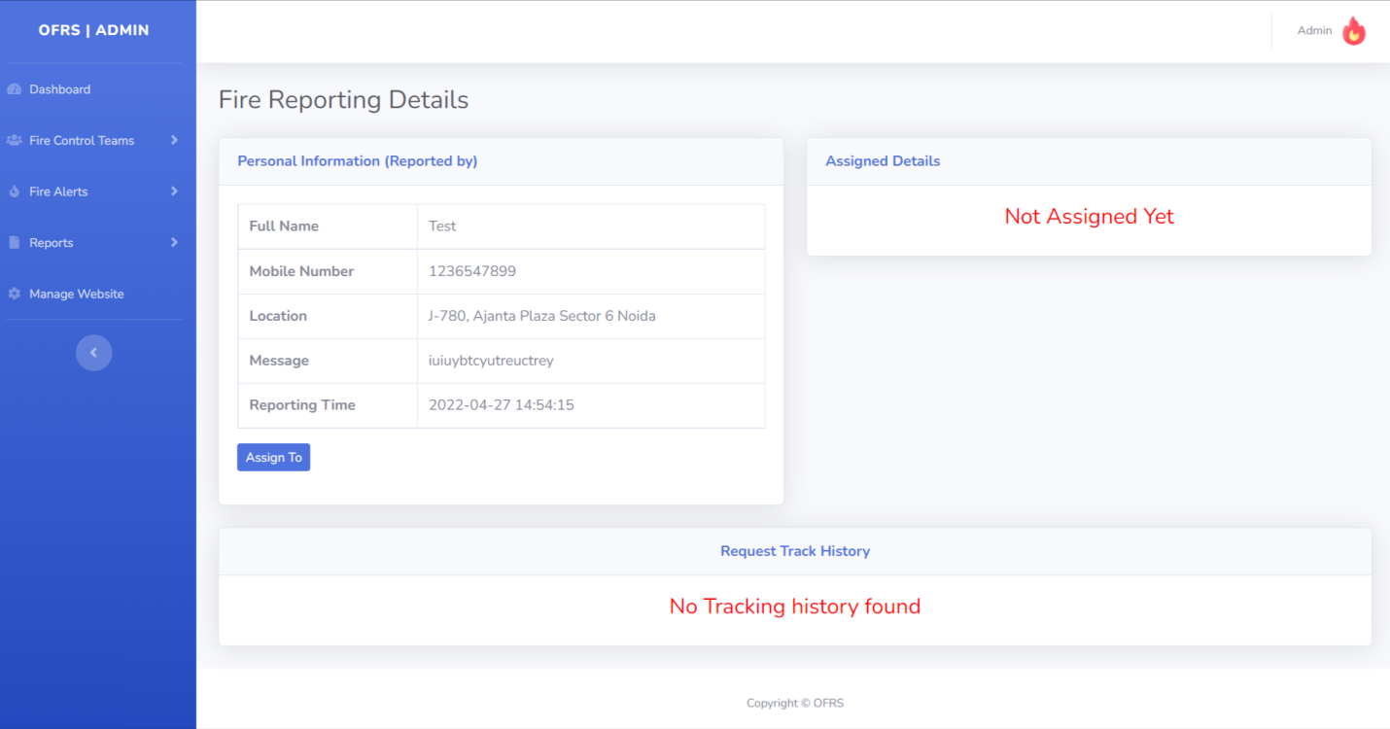

**Assigned Fire Request**

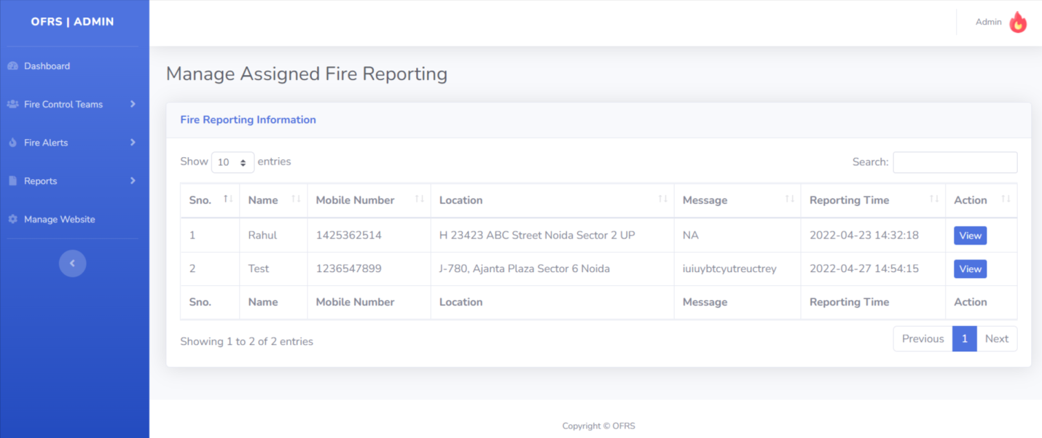

**View Assigned Fire Request**

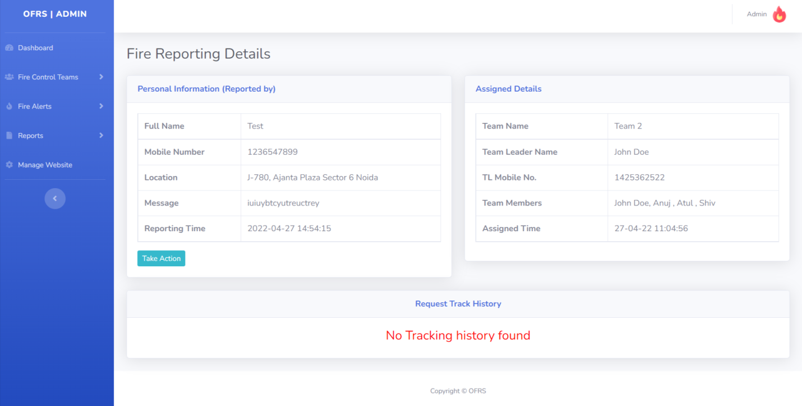

**Team On the Way Fire Reporting**

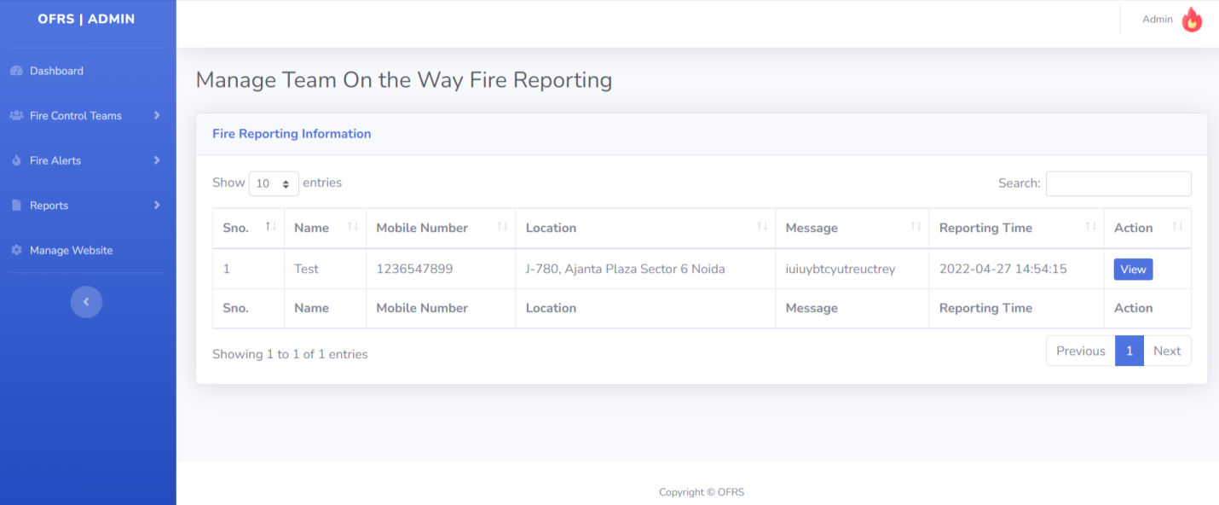

**View Team On the Way Fire Reporting**

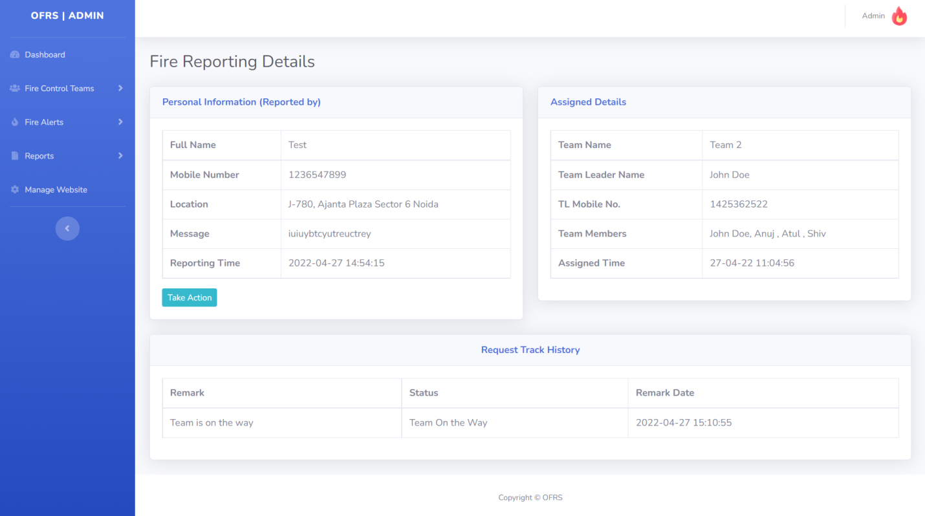

Relief Work in Progress Fire Reporting

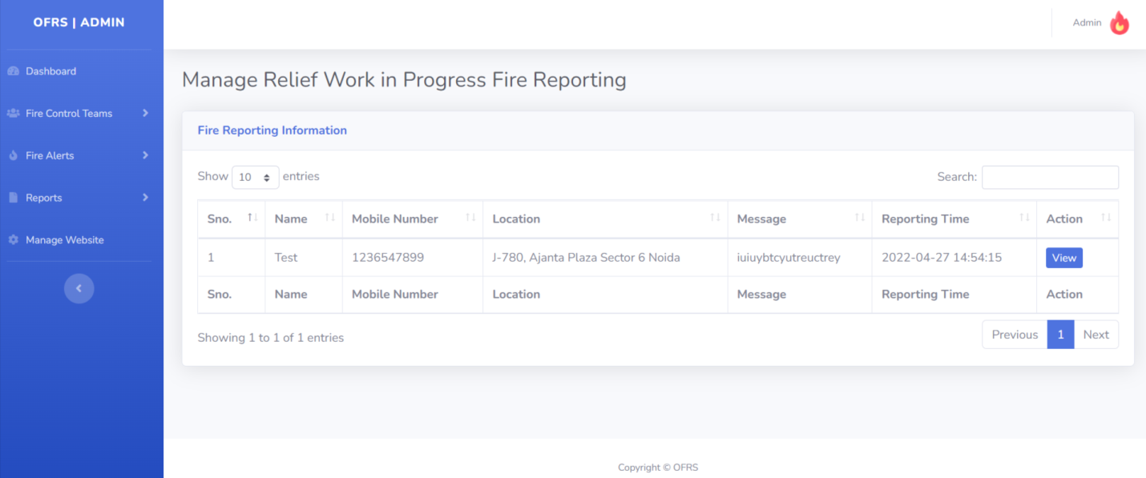

# View Relief Work in Progress Fire Reporting

# 

# Completed Fire Reporting Request

# 

# View Completed Fire Reporting Request

# 

# Between dates reports

# 

# View between dates reports

# 

# Manage Website

# 

**Conclusion**

This Application provides an online version of Online Fire Reporting System which will benefit the fire handling team to maintain fire incidents details and fire team details.

It makes entire process online and can generate reports.

The Application was designed in such a way that future changes can be one easily. The following conclusions can be deduced from the development of the project.

* Automation of the entire system improves the productivity.
* It provides a friendly graphical user interface which proves to be better when compared to the existing system.
* It gives appropriate access to the authorized users depending on their permissions.
* It effectively overcomes the delay in communications.
* Updating of information becomes so easier.
* System security, data security and reliability are the striking features.
* The System has adequate scope for modification in future if it is necessary.

**References**

**For PHP**

* <https://www.w3schools.com/php/default.asp>
* <https://www.sitepoint.com/php/>
* <https://www.php.net/>

**For MySQL**

* <https://www.mysql.com/>
* [http://www.mysqltutorial.org](http://www.mysqltutorial.org/)

**For XAMPP**

* <https://www.apachefriends.org/download.html>